**SAP HANA VIEWS**

**Authored By**

Divya Jayaprakash (dxj160830)

MIS 6345.0W1 - High Performance Analytics - Spring 2017

Professor. Mr. Kashif Saeed

**Created Views:**

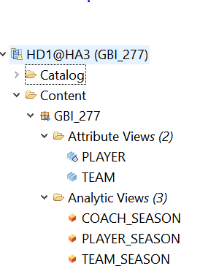

**Attribute View: Player**

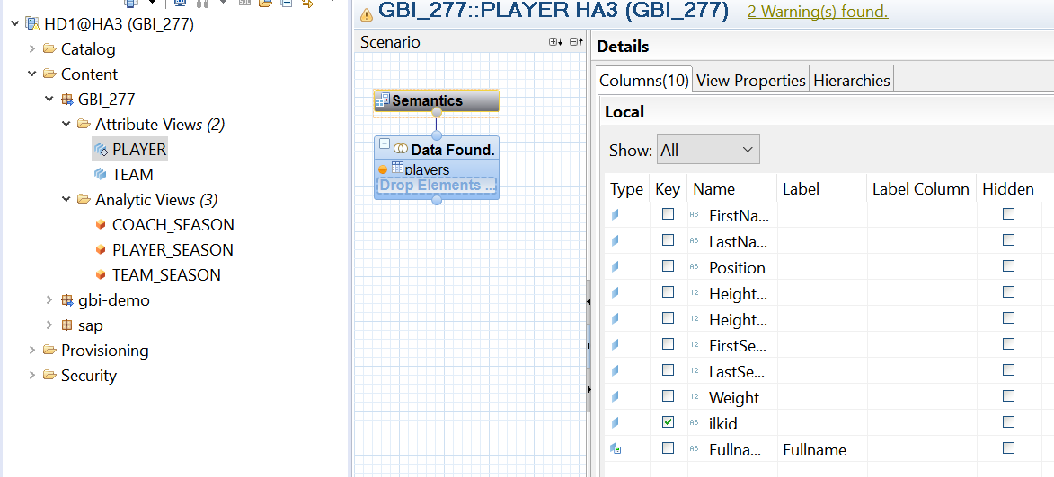

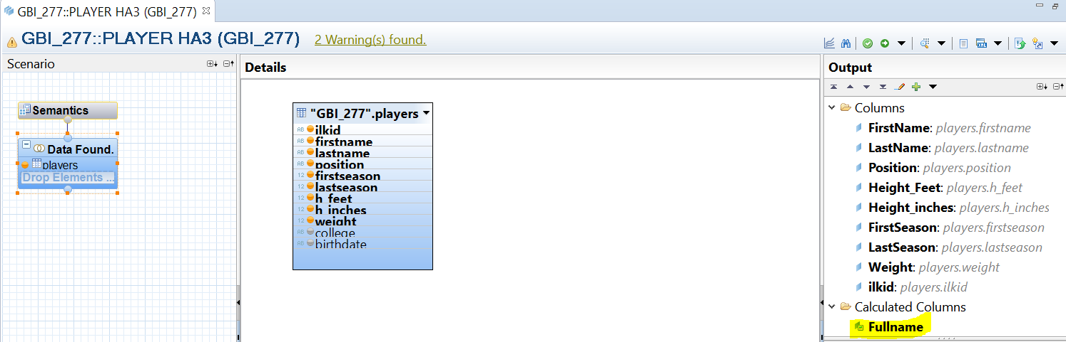

**Raw Data of the Player View:**

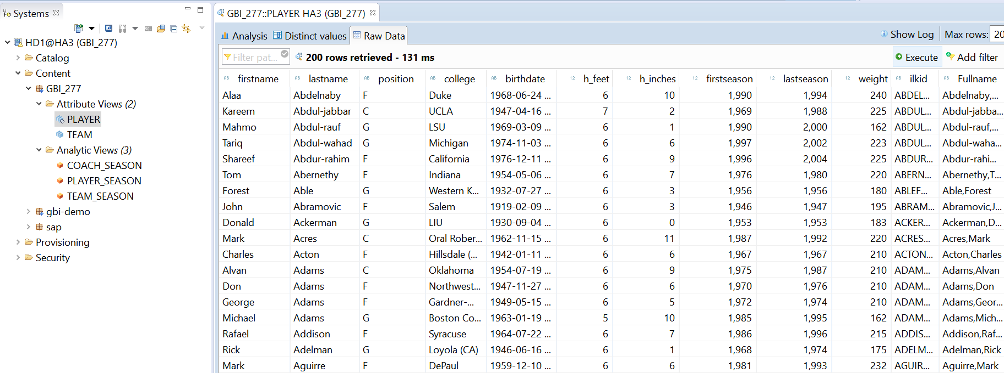

**Attribute View: Team**

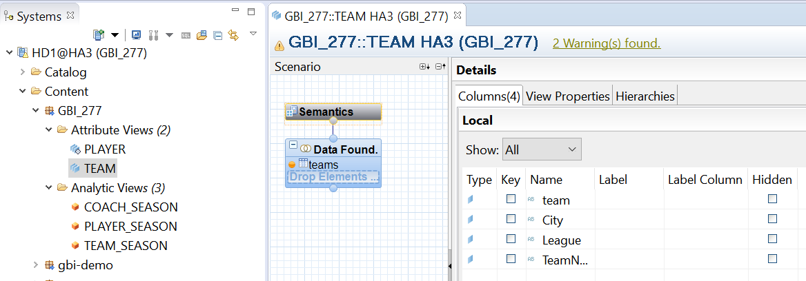

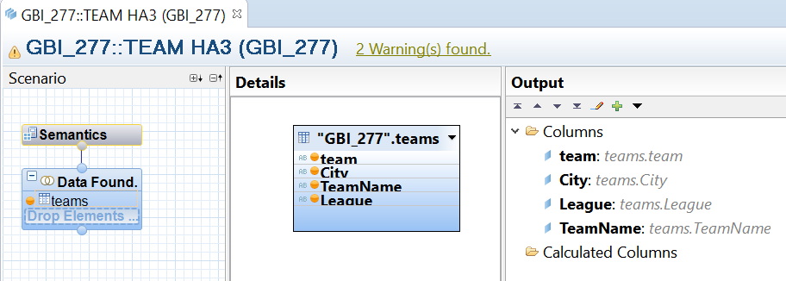

**Raw Data of the Team View:**

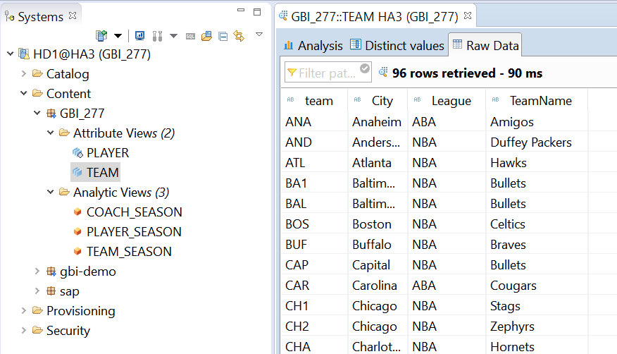

**Analytic View: Player_Season**

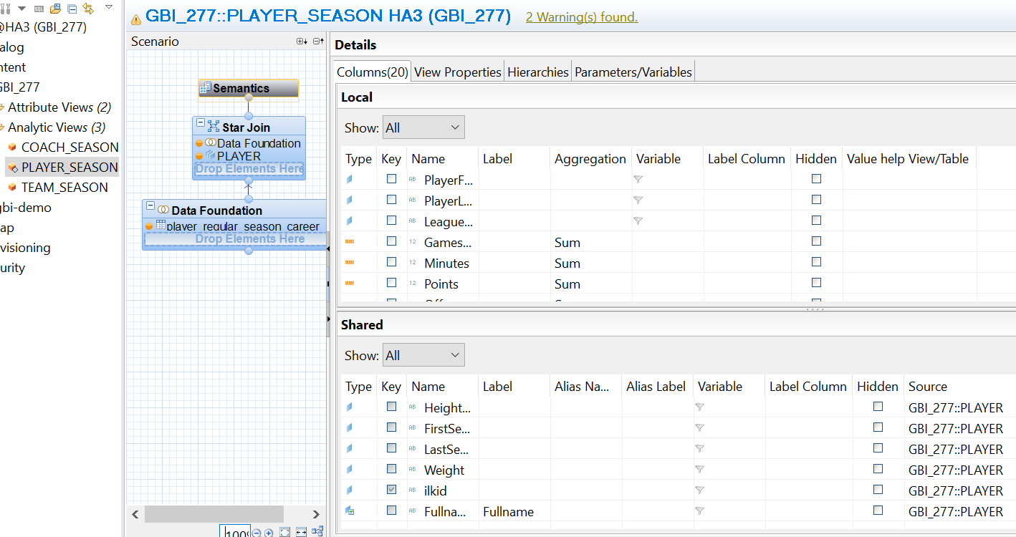

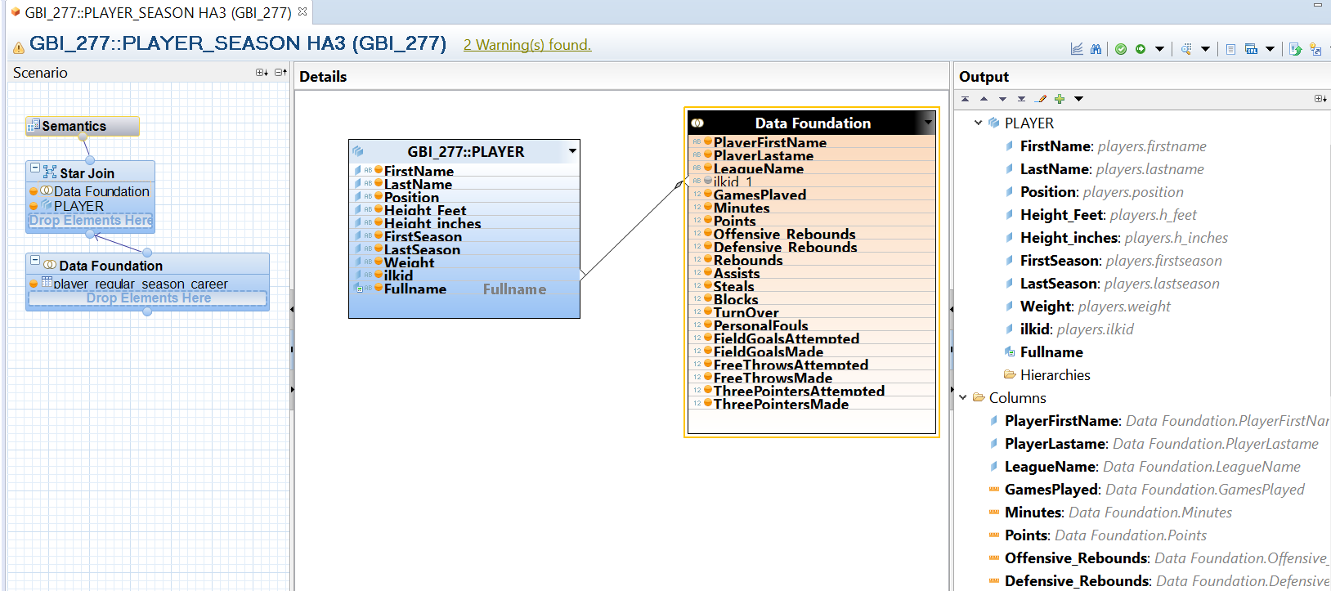

**Raw Data of the Player_Season View:**

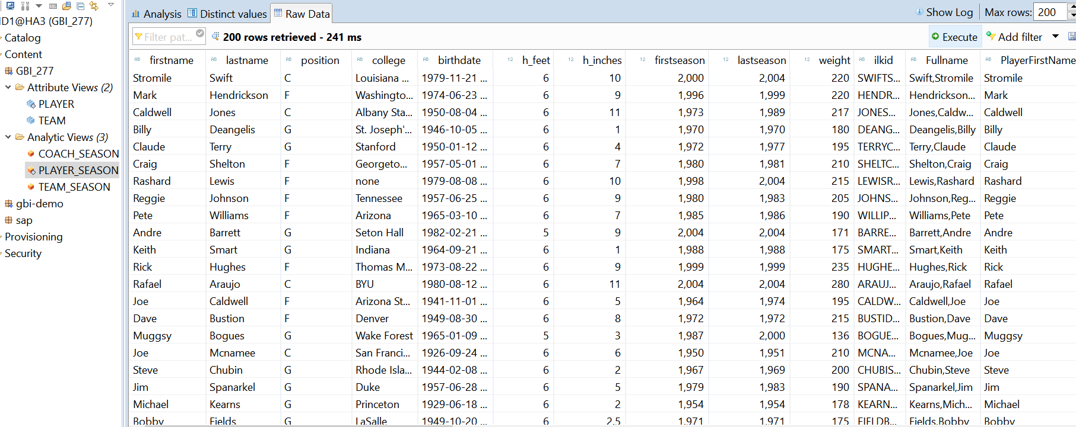

**Analytic View: Team_Season**

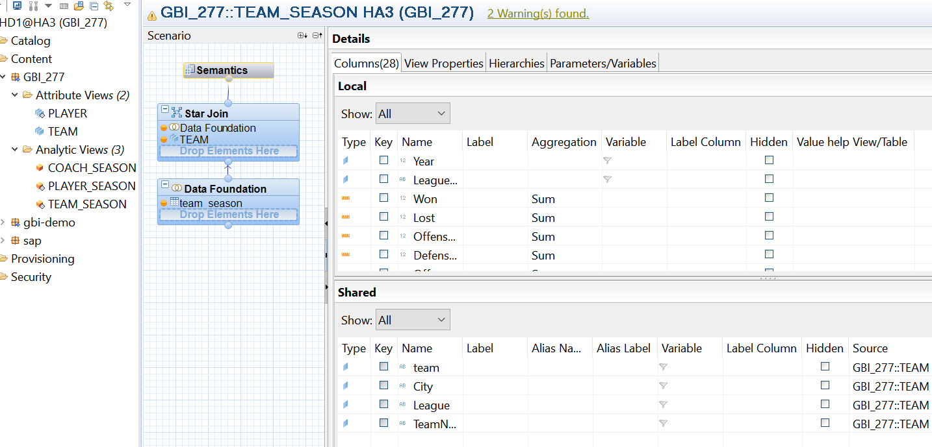

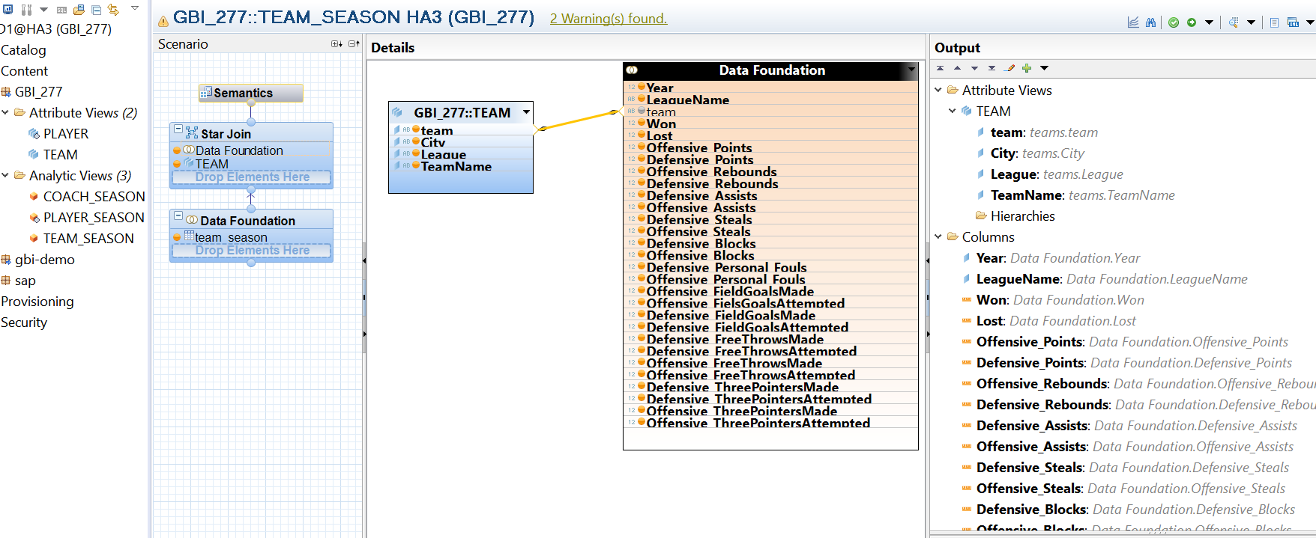

**Raw Data of the Team_Season View:**

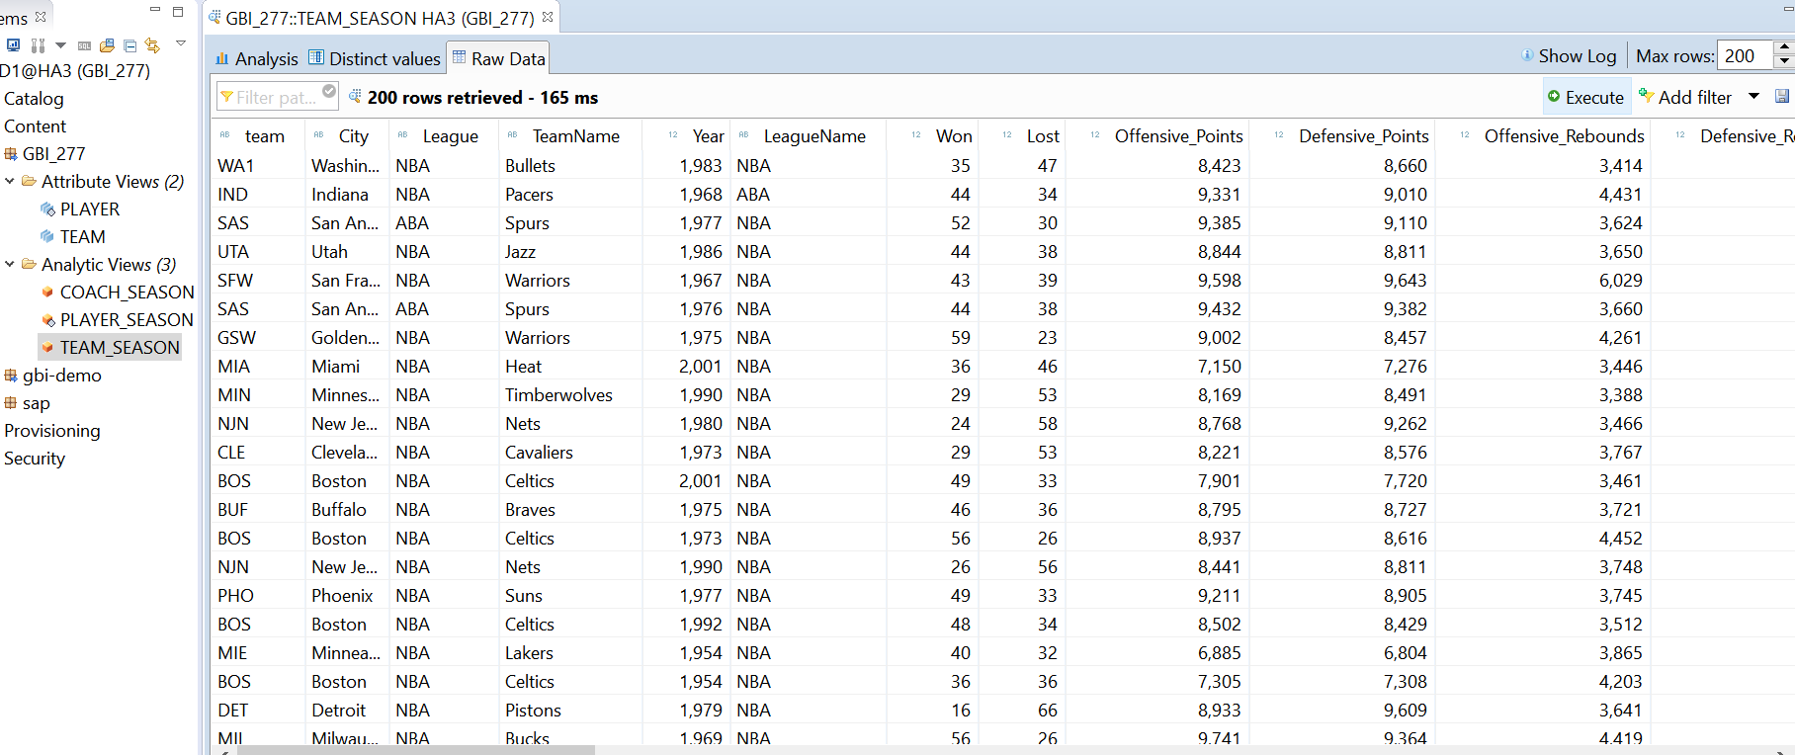

**Analytic View: Coach_Season**

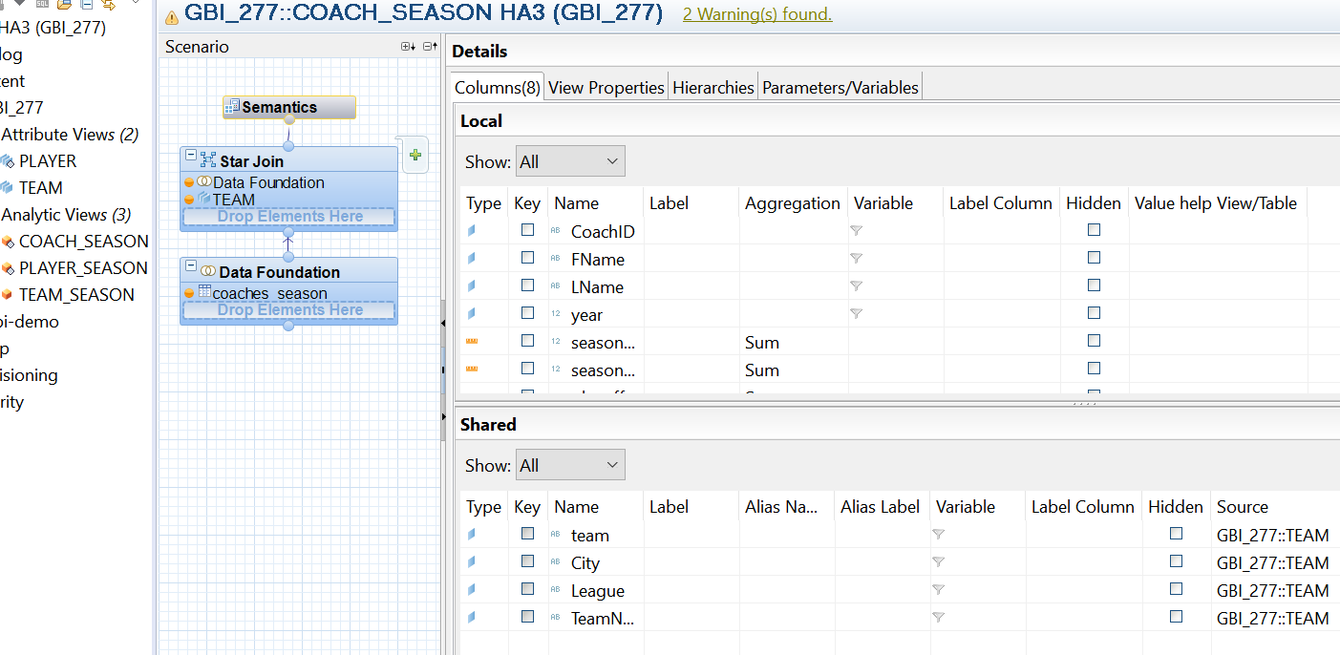

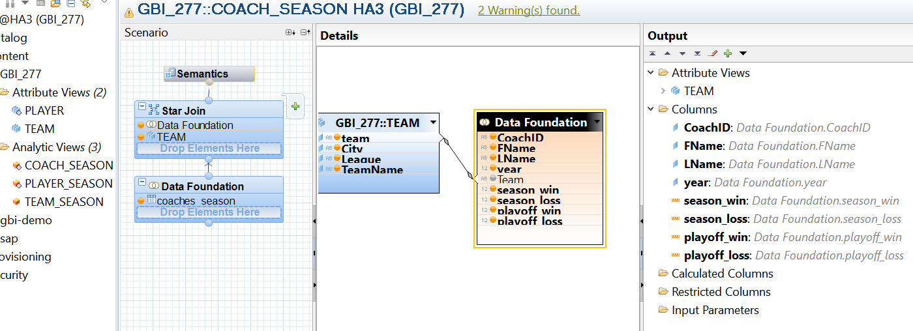

**continued…**

**Raw Data of the Coach_Season View:**

